Author: Max Slocum  
*********************************************************************  
Before you begin this tutorial make sure you know the login credentials needed for the SSH server. Additionally download and install Putty ahead of time.   
*********************************************************************

Open PuTTY and go over to the **Category** section.

Then click: **Connection->SSH->Tunnels**

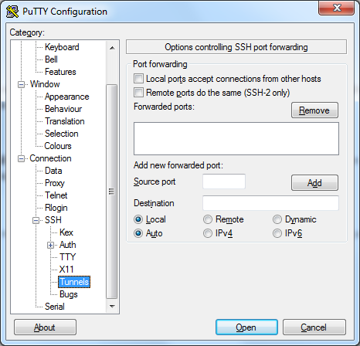

Check **Dynamic** and click **Add**. You should now see something like this:

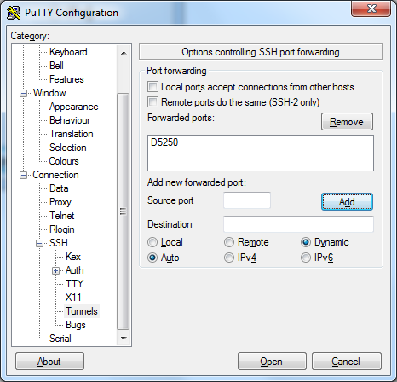

Than go back to the sessions tab and enter this information in

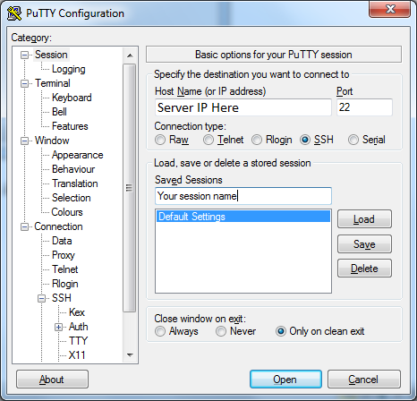

Hit save to save the session so you don’t have to enter the information next time and it will pop up in the list of sessions

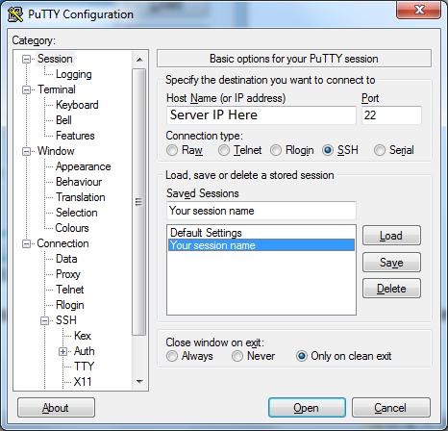

PuTTY may prompt you like this, just click **Yes**.

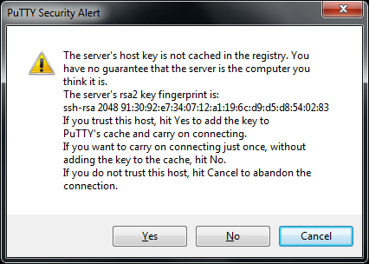

Enter your **username** and **password** like so:

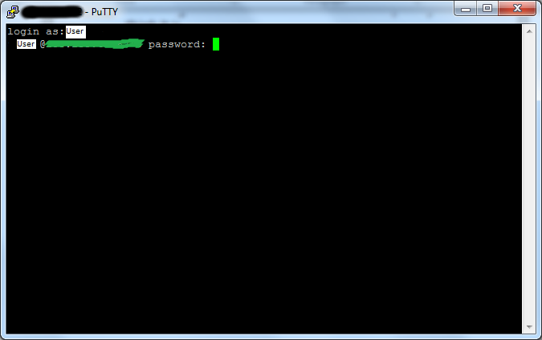

The console will login and look something like this if successful: 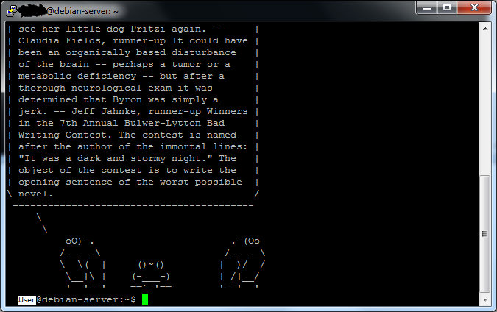

Minimize the window but don’t close it. If you do it will end the connection

Next setup the firefox proxy connection. Here is a picture of what it looks like.

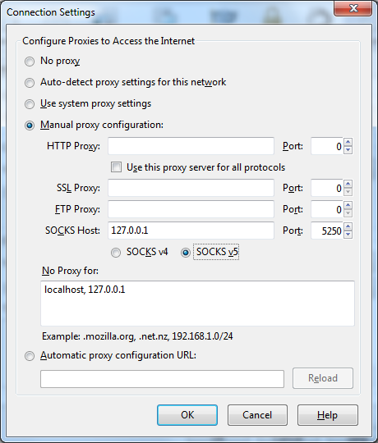

Now Firefox should run fine for anything you need.